2022 Virginia Maiden Sponsorship Form

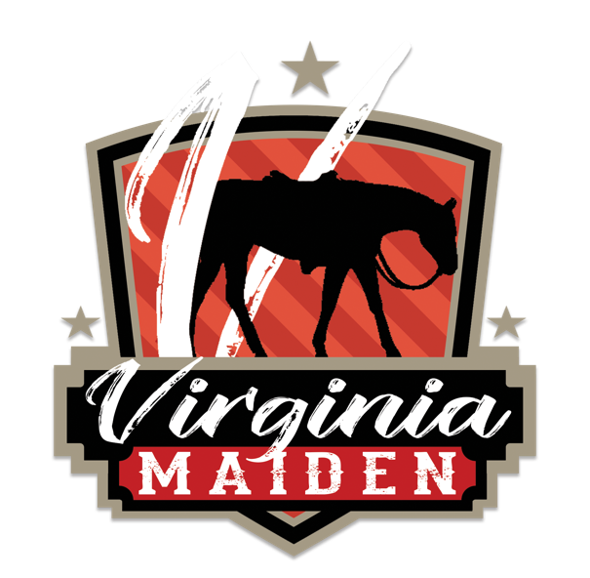

THE VIRGINIA MAIDEN is dedicated to promoting young western pleasure and hunter under saddle horses, their trainers, and their owners. We are a horse show ran by a small group of people whose primary goal is to give back to the industry that we have dedicated our entire lives to. Due to the fact that we are such a young and small organization we do rely on the generous donations of our sponsors. As we grow, we will be able to offer our exhibitors and sponsors more incentives, but in order to do that we need your help!! We offer our sponsors many marketing tools and some benefits at the horse show depending on the level of sponsorship. Our social media platform has been a great asset to our sponsors in the past. The Virginia Maiden Facebook page has reached over 1500 followers and is growing every day. Our post and sponsor ads have reached thousands of viewers in and out of the horse community bring great exposure to their businesses and horses. It’s also a great way to show that they are giving back and are truly invested in the future of our industry. On top of our social media presence, The Virginia Maiden advertises in multiple equine publications such as The Equine Chronicle and InStride Edition which reach countless equine professionals and enthusiast! Please take a look at the sponsorship packages below and let us know what you would be willing to do! THANK YOU!!!

Gold Sponsors:
- $5000+
- Name and Large logo in Equine Chronicle ad.
- Logo and name in individual Facebook post weekly on the Virginia Maiden Page.
- Multiple Boosted posts on Facebook
- Name and large logo on Gold Sponsor Banner at the VQHA Spring Breakout
- Name Mentioned Multiple times the night of the class as well as being a part of the awards ceremony (if you’d like to help hand out awards).
- Priority Stalling assuming the stalls have not already been purchased.
- Late fee waved if you have a late entry to the class.
- Sponsor Gear.
- Access to our email list.
- Free Vendor space.
Silver Sponsors:
- $1000-$4999
- Name and small logo in Equine Chronicle ad.
- Logo and name in individual Facebook post on Virginia Maiden page.
- Facebook post will be boosted to reach additional audience.
- Name and small logo on Silver Sponsor banner at VQHA Spring Breakout.
- Name mentioned at the horse show and the night of the class.
- Sponsor Gear
- Free vendor space.

Bronze Sponsors:
- Less than $1000
- Name listed in Equine Chronicle ad.
- Logo and name in individual Facebook post on Virginia Maiden page.
- Name listed on Bronze sponsor banner at VQHA Spring Breakout.
- Name mentioned at the horse show and the night of the class.
- Small sponsor gear

General Info For Sponsors:

- The Virginia Maiden is a western pleasure and hunter under saddle futurity that will be held during the VQHA Spring Breakout quarter horse show that will be held in Lexington, VA.
- ALL SPONSORS ARE HIGHLY ENCORAGED TO SEND BANNERS AND SIGNS WITH THEIR SPONSORSHIP!!!!!
- Please fill out the form below and send it to Cameron Van Sickle at 678 WC Braswell Rd. Selma, NC 27576.
- Make Checks Payable to The Virginia Maiden.

Sponsor Information

Name:

Business:

Address:

Phone:

Email:

Name Listed
On Ads and
Banner:

Level of Sponsor: Bronze (Less than $1000)

Silver ($1000 - $4999)

Gold ($5000 and up)

Shirt Size (for sponsor gear):

- Please print this form, fill it out, and send it to Cameron Van Sickle at 678 WC Braswell Rd. Selma, NC 27576
- Make Checks Payable to The Virginia Maiden.
- Please send a banner we can hang up at the horse show if you have one!

Thank You So Much!!!

