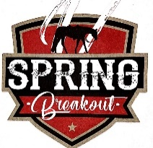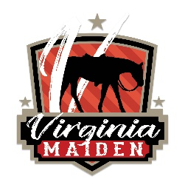

2024 Spring Breakout/Virginia Maiden Sponsorship Levels
Sponsorship Levels - These are the Sponsorship levels created for this show. Sponsors of all types are appreciated.
If there is something more specific, please feel free to contact us.
Gold Sponsors ($5,000+) - Includes Name and logo in national advertising, Logo and Name in individual Facebook post on the Virginia Maiden Page and Spring Breakout Page, Logo and Name on Spring Breakout website, Name and Large Logo on Sponsor Banner at the show, Name and/or logo on yard sign, Announcements throughout the show, assistance with awards presentation (if desired), Priority Stalling in Barn 5 or 6 (or other agreed location), One late fee waived if you have a late futurity entry, Sponsor Gear and Gifts, Free Vendor Space. Name/Logo to be listed on the Pattern Book and show wrap ups.
Silver Sponsors ($1,000-$4,999) - Includes Name and logo in national adv, Logo and Name in individual Facebook post on the Virginia Maiden page and Spring Breakout Page, Logo and Name on Spring Breakout website, Name and Logo on Sponsor Banner at the show, Name and/or logo on yard sign, Announcements at the show, sponsor gear and gifts, priority stalling in Barn 7 or 1 (or other agreed location), Free Vendor Space. Name/Logo to be listed on the Pattern Book and show wrap ups.
Bronze Sponsors ($200-$999) - Name listed in Equine Chronicle ad, Logo and Name in Facebook post on the Virginia Maiden page and Spring Breakout Page, Name listed on Spring Breakout website, Name listed on sponsor banner at the show, Name and/or logo on yard sign, Announcements during the show, sponsor gear.
Spring Breakout All Around/High Point Sponsor ($150) – Name and logo listed on display with the award in the show office, Periodic announcements at the show, Name listed on Spring Breakout website, Name/Logo to be listed on the Pattern Book and show wrap ups.
Spring Breakout Class Sponsor ($30-$100) - Class sponsorships are available for $30/class or 4 classes for $100. Your name will be announced during the class at the show. Listed on the Pattern book and show wrap ups.
Buckle Sponsor ($100) - $100 per buckle. Your name will be announced during the class at the show. Listed on the Pattern book and show wrap ups.

**We welcome merchandise as well as cash.

On behalf of the Spring Breakout and Virginia Maiden Team -
Thank you for your support of our show! Without sponsors like you we could not make this event possible.

If you have any questions, please call Suzanne Gonzales 703-201-2915, suzannegonzales228@gmail.com, or Meghan Tierney 973-303-6804, meghanmorse22@gmail.com, or Cameron Van Sickle 704-591-2980, cameronvansickle93@gmail.com

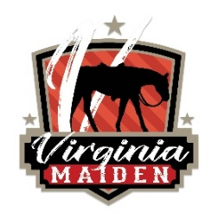

2023 SPONSORSHIP FORM

Name of Sponsor*(required) …………………………………………………………………………………………

What is the name you would like the Sponsorship listed under?....................................................................

…………………………………………………………………………………………………………………………..

Name of Stalling Agent*(required)…………………………………………………………………………………..

What is the name of the stalling agent this sponsorship should be counted towards?..................................

………………………………………………………………………………………………………………………….

Name of Sponsor Representative*(required)………………………………………………………………………

Address of Sponsor*(required)………………………………………………………………………………………

Phone of Sponsor Representative*(required)………………………………………………………………………

Email of Sponsor Representative*(required)……………………………………………………………………….

Sponsorship Level
Virginia Maiden Gold Sponsor ($5,000+)
Virginia Maiden Silver Sponsor ($1,000-$4,999)
Virginia Maiden Bronze Sponsor ($1-$999)
Virginia Maiden Custom Sponsor
Spring Breakout All Around/High Point Sponsor ($100)
Spring Breakout $30 per class or 4 Classes for $100

Please circle:

GOLD SILVER BRONZE CUSTOM ALL AROUND CLASS(ES)

Please provide a description of your sponsorship, i.e., which classes you wish to sponsor, is your sponsorship in cash or merchandise. If merchandise, please describe.

…………………………………………………………………………………………………………………………

…………………………………………………………………………………………………………………………

…………………………………………………………………………………………………………………………

………………………………………………………………………………………………………………………….

………………………………………………………………………………………………………………………….

………………………………………………………………………………………………………………………….

